For Starbiz:

PLEASE TRUNCATE ENTIRE DATABASE AND START TESTING FROM SCRATCH.
- INVITATIONS
- Notifications SHOULD BE GENERATED ON EACH STATUS CHANGE
- Notifications SHOULD BE GENERATED ON EACH COMMENT
- Status should be updated in both portals for each status change.
- DESIGN ISSUE:
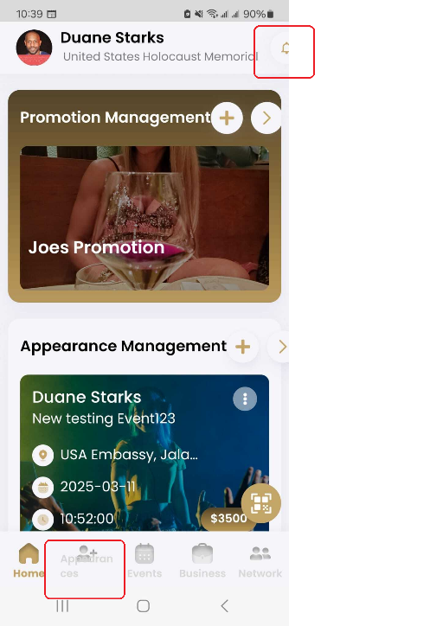
Samsung Galaxy S22 5G

- SUBSCRIPTION –
Package should show what all features are available and how many units
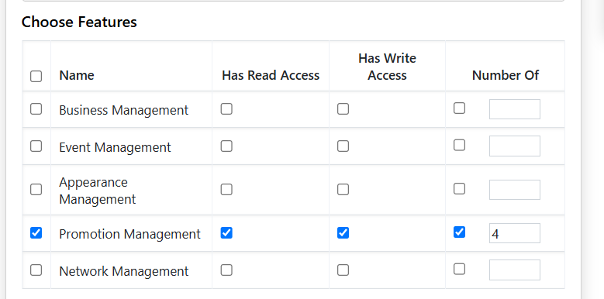
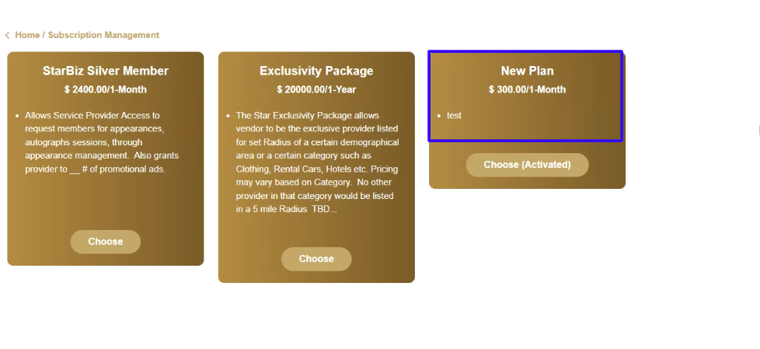

- SEARCH FOR EVENTS + A & E ON INVITATION SCREEN
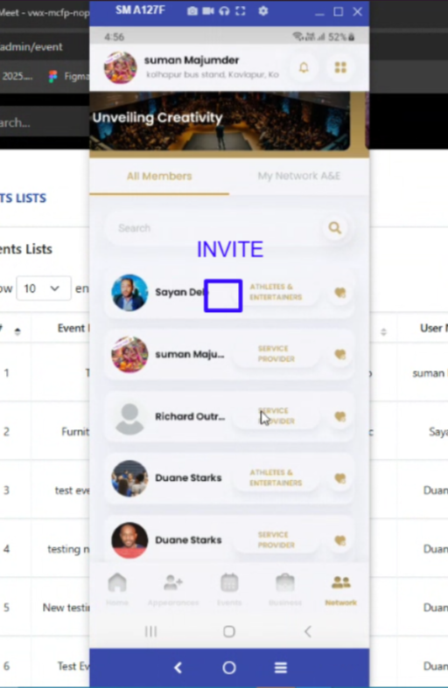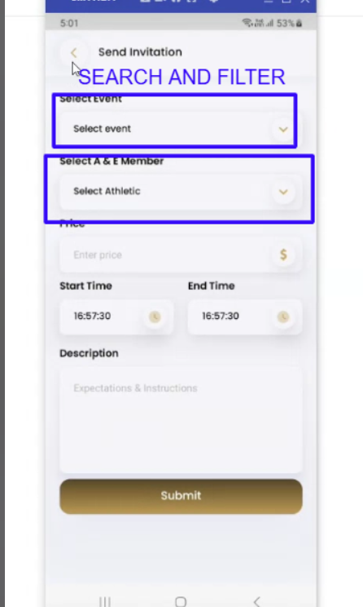

- Referral Code: SHOULD EXPIRE IN 7 DAYS - AUTO GENERATED UNIQUE VALUE

